**Part I: Hybrid Images**

For the hybrid image part, two images were chosen one each of a lion and a man. The results of the hybrid image was the best of the three that had been created. The function that was created for outputing the hybrid images applied a Gaussian filter to the gray scaled image of choice giving us a low passed image. This was followed by a Laplacian filter to the other image of choice by first applying a Gaussian filter to the gray scaled image and then subtracting that from the original gray scaled image giving us a high passed image. The high and low passed images were then added together. The resulting image shown in figure 3 shows the lion as the high passed image and the man as the low passed image combined together. One of the ways used to test which sigma value to use for the Gaussian filtered image was to do a for loop that would increment up one each time while doing the same for the Laplacian filter. This gave many images to choose from and from those the best was chosen. When doing an analysis of

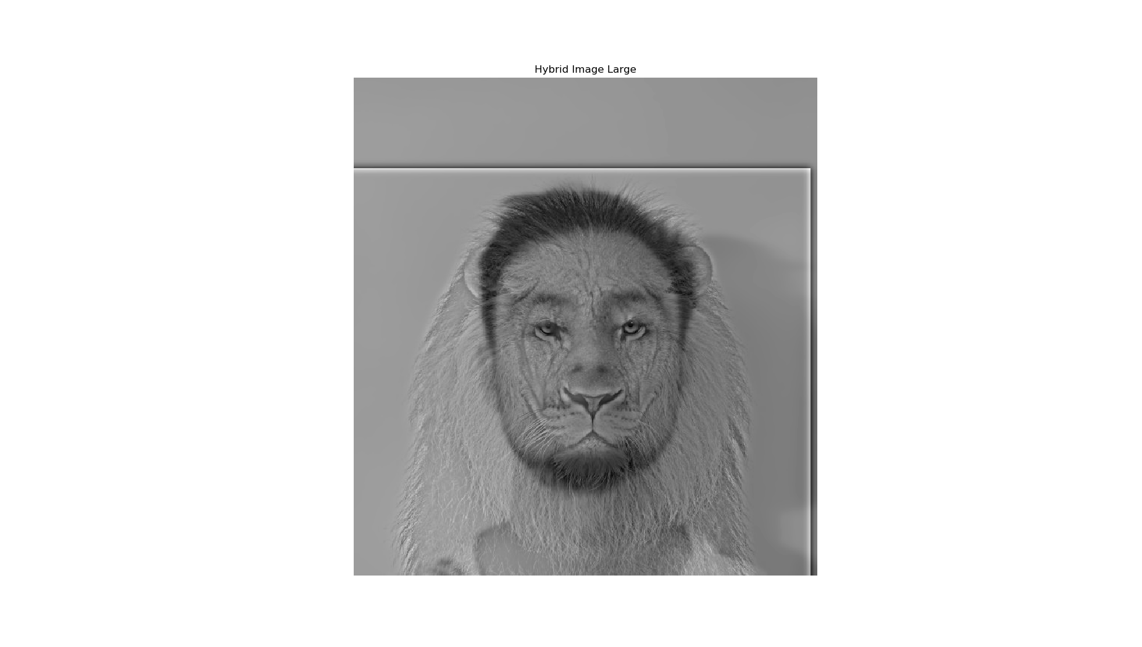

*figure 3*

*figure 2*

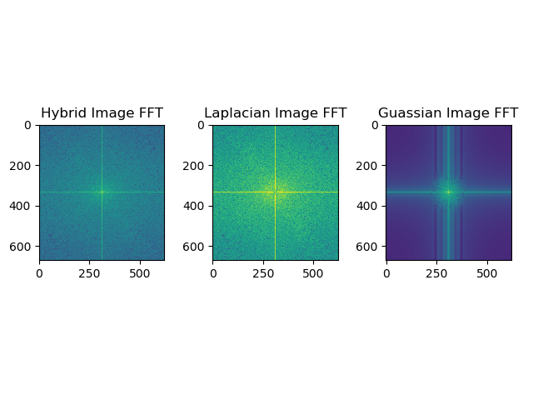

*figure 1*

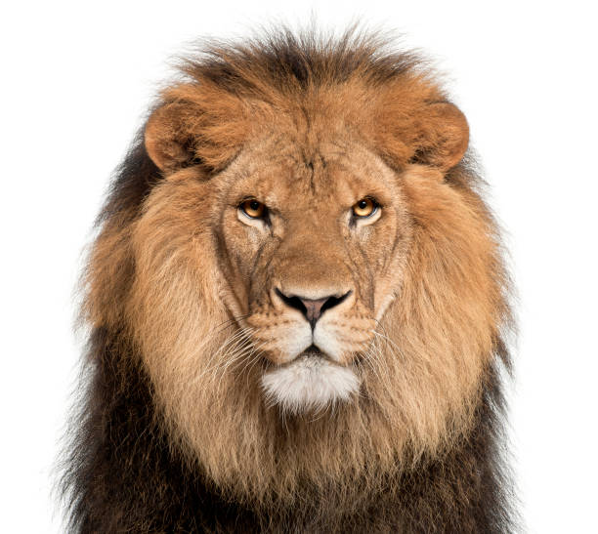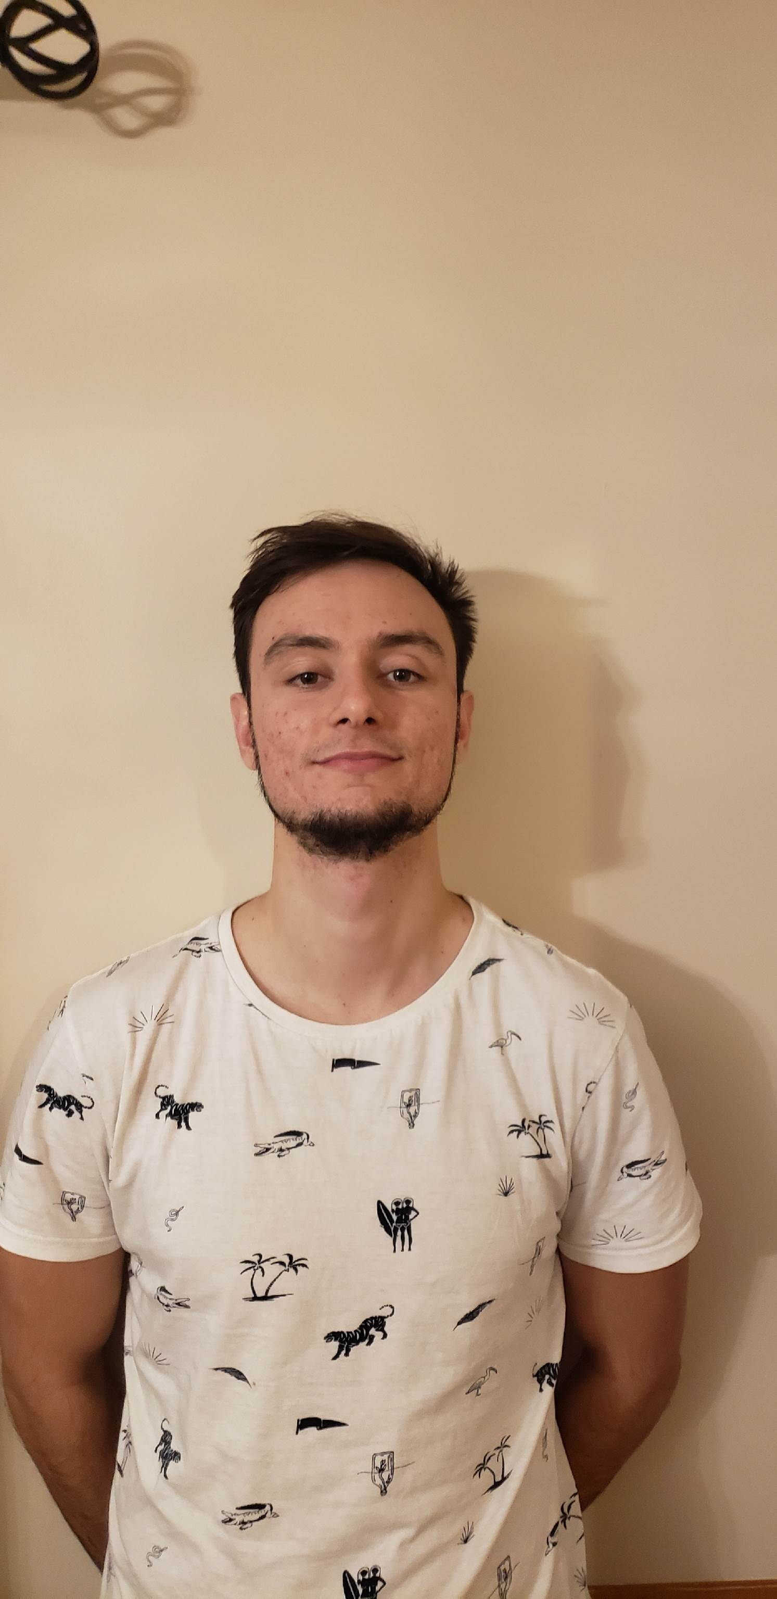

the FFT plots (figure 2) it was found that the Gaussian filtered image had filtered out almost all the high frequency while the Laplacian filtered out all the low frequencies which resulted in a nice plot for the hybrid image.

The same process was done for two other hybrid images. The images shown in figure 4 were applied to the same function as described before. The resulting image turned out not as good as the lion one. One of the reasons was the orientation of the girl in the photo was more sideways then the cat resulting in the aligned images being more rotated. The other problem was when the low pass filter was applied there was still some noise in the high frequencies areas show in the FFT plot of the Gaussian image in figure 5. The resulting image shown in figure 6 shows the cat as the high

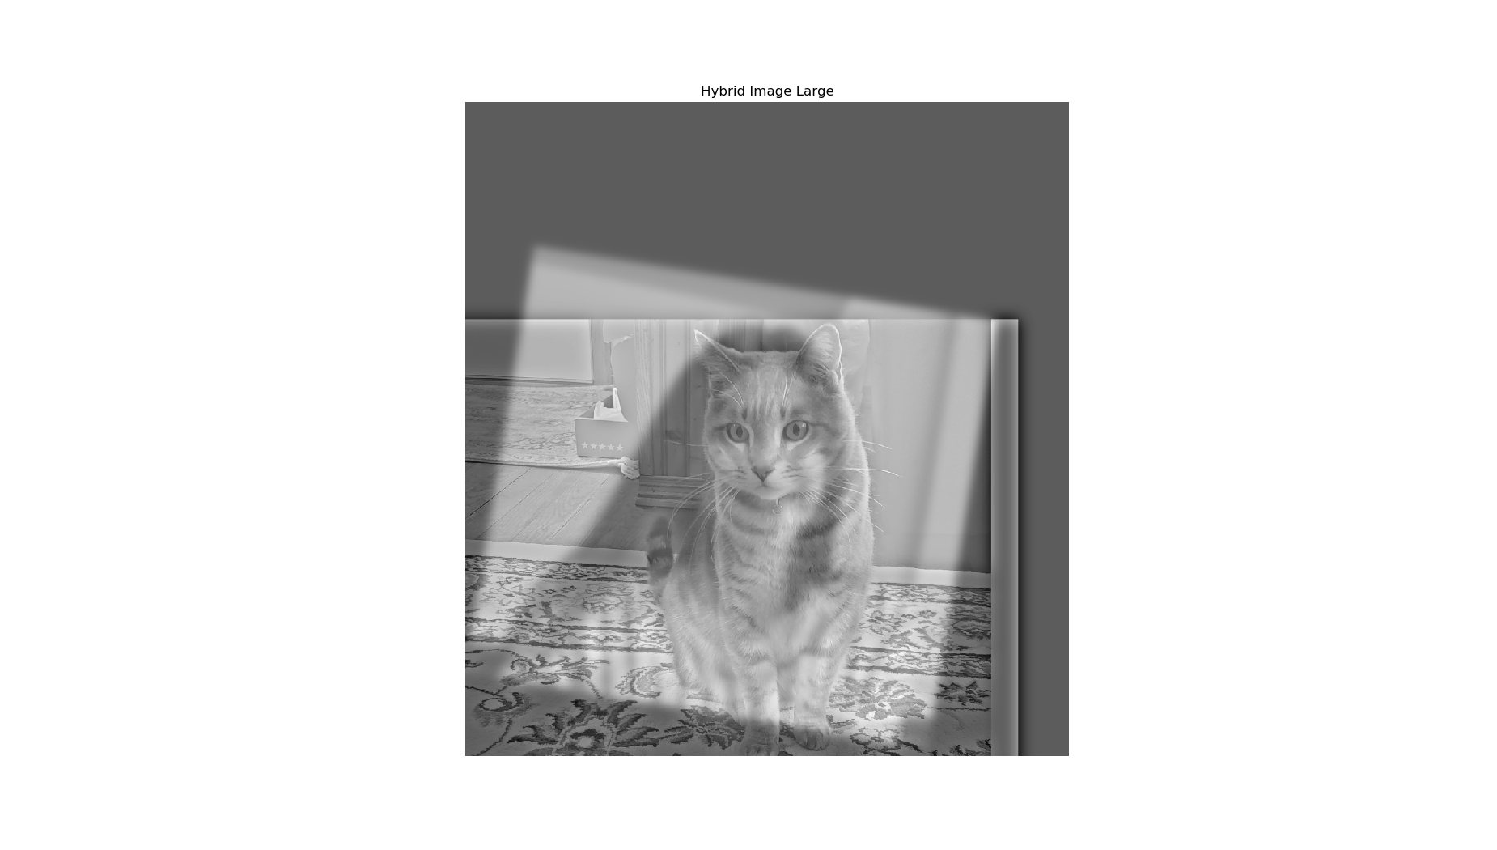

*figure 6*

*figure 5*

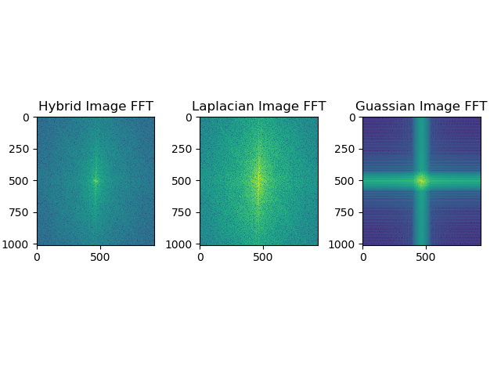

*figure 4*

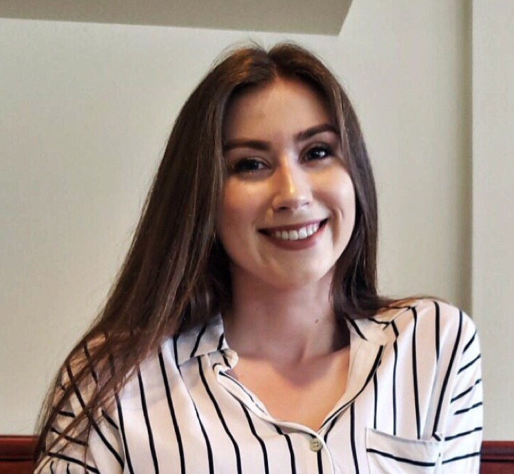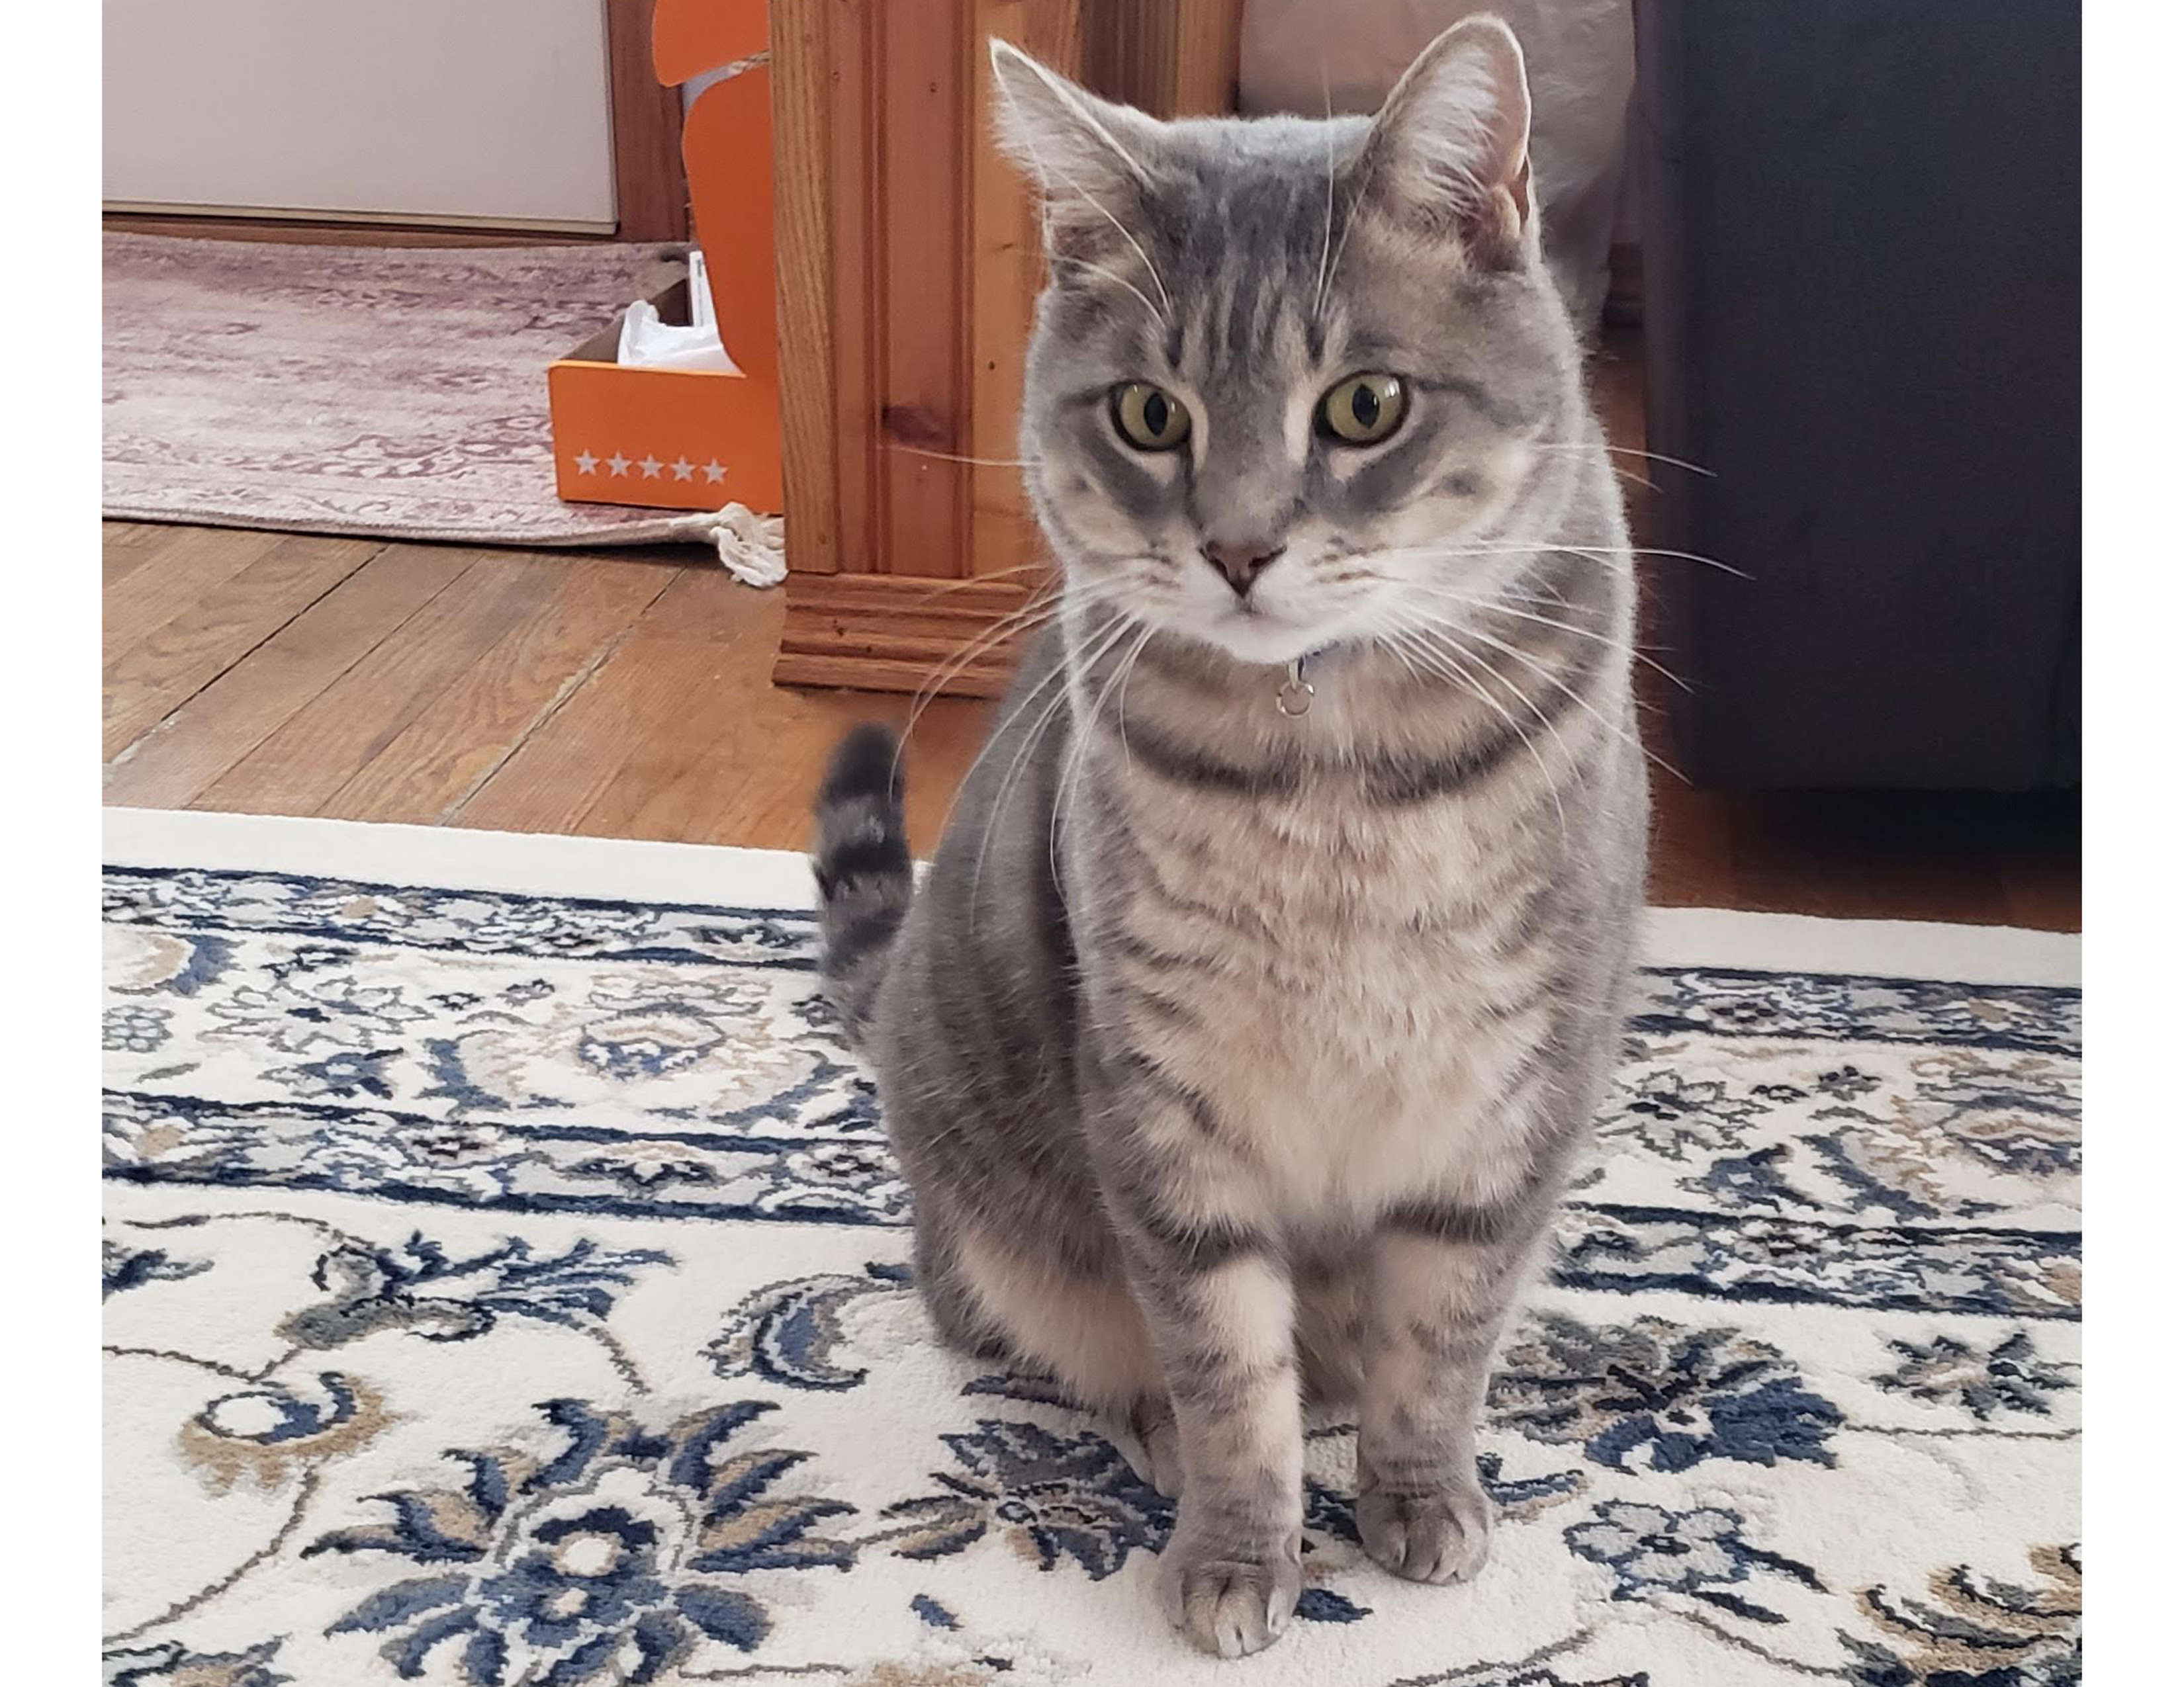

passed image and the girl as the low passed image combined together.

The last image that was created involved using two pictures of brothers show in figure 7.

*figure 7*

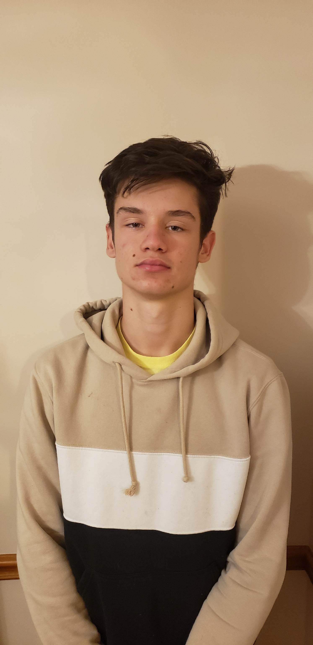

It is a little bit more difficult to tell the difference of the hybrid image when looking at it from close and far because the faces are alreay similar enough. This took a little bit more trial and error to get the correct sigma value for each image. The FFT plot show in figure 8 came out suprisingly well similar to that of the lion image.

*figure 10*

*figure 8*

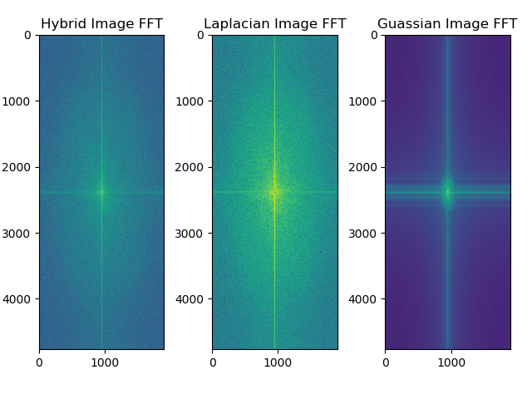

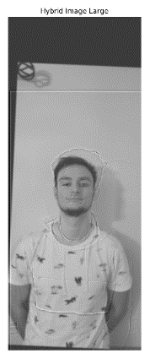One of the problems also was the allignment of the hairs on both heads and the beard that could be seen both far and close up which was only in one of the images. The resulting image is shown in figure 9.

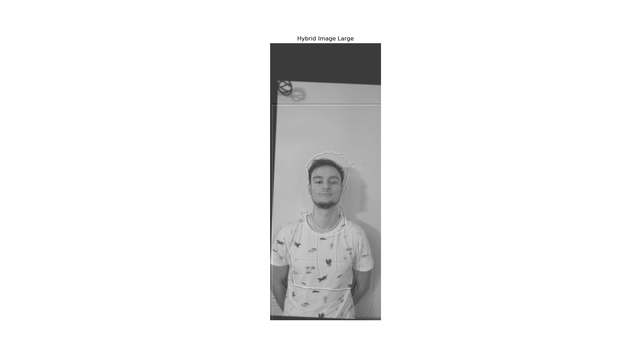

*figure 9*

**Part II: Image Enhancement**

**Contrast Enhancement**

For this part a photo of a group of friends is seen in figure 10 which was taken in lower light that is difficult to see and also a little blurry.

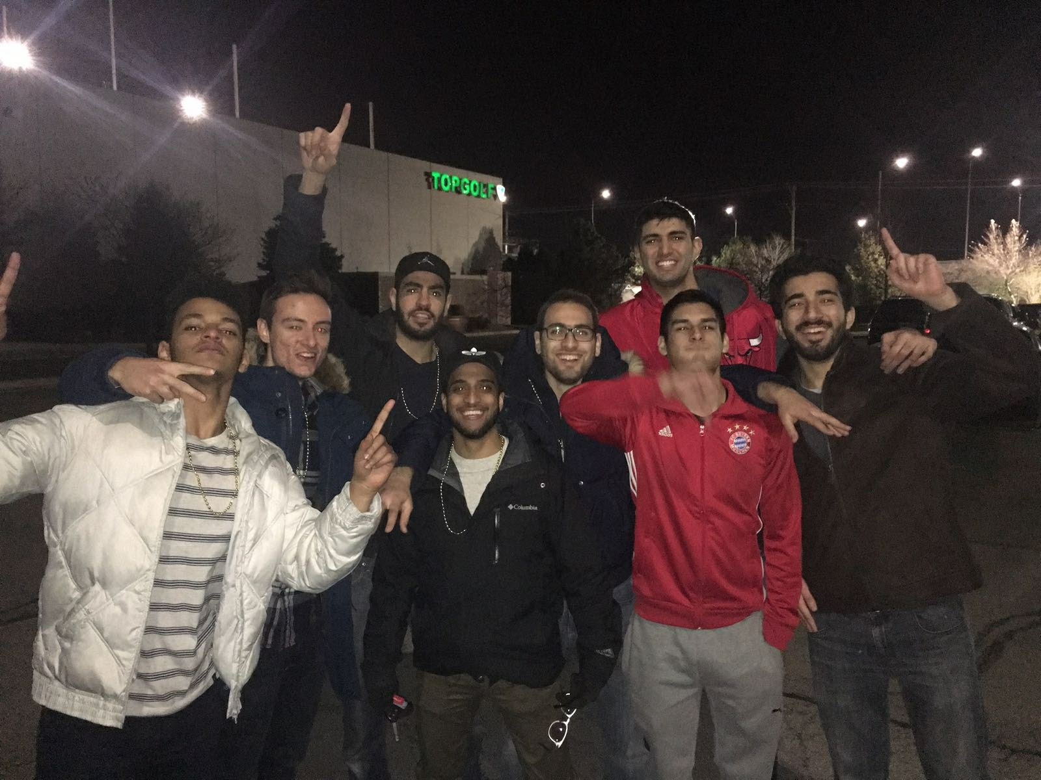

Histogram equalization was used to edit the image by first converting the image to the HSV color space. Then the built-in histogram equlization function in opencv2 was used on the value channel. Finally the image was converted back to the RGB domain to output it.

*figure 11*

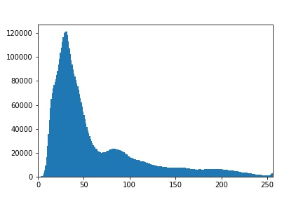

The orginal image had more dark values, this is shown in the histogram of figure 11. The equalized image had a better distribution of values, which is shown in figure 12.

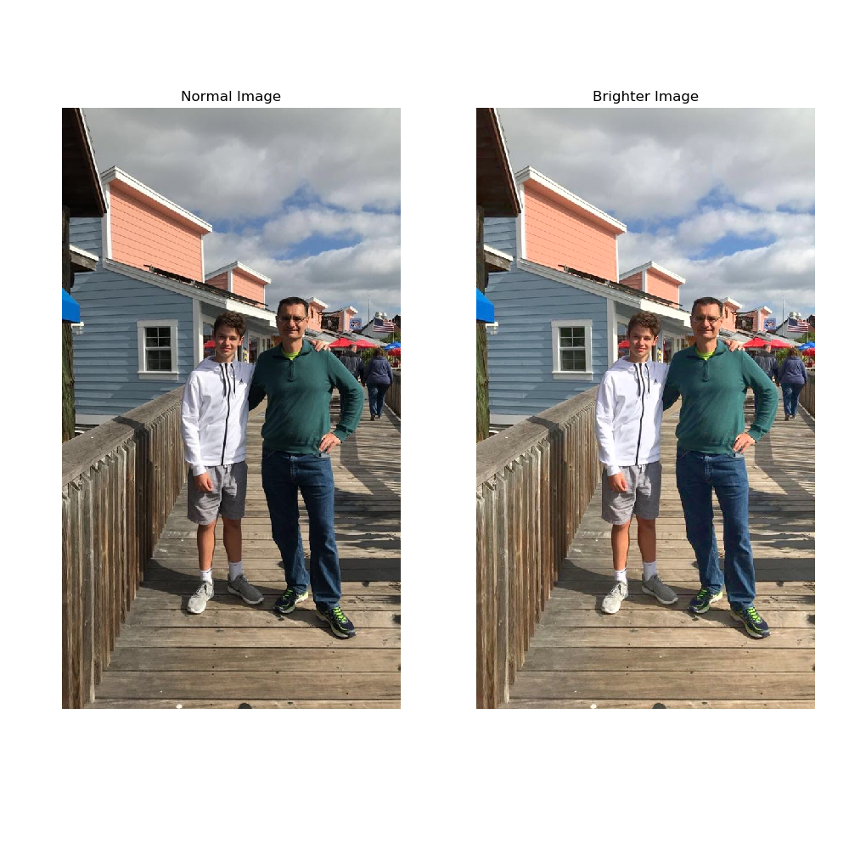

*figure 12*

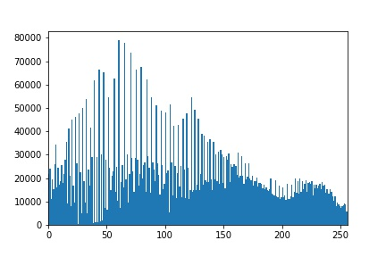

This was used over gama correction to get a better distribution of values and not just change every value by a multiplier. The final image is shown below in figure 13. 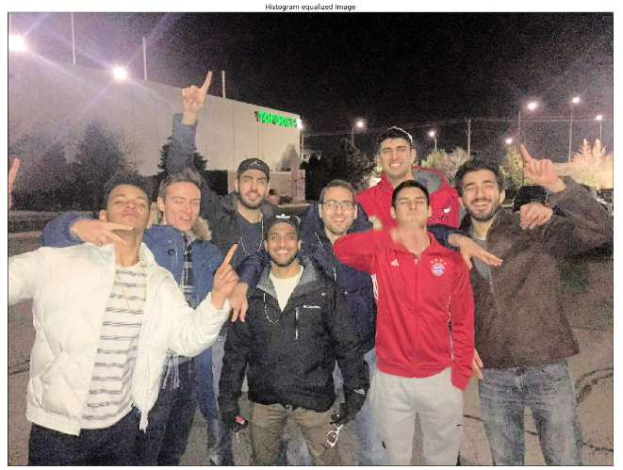

*figure 14*

*figure 13*

**Color enhancement**

Color enhancment was done to an image by converting it again to the HSV color space. The value is associated with how bright an image is. To get more vivid colors, many values were experiment to get the correct lighting to an image. Ultimetly it was chosen to linearly add 24 to the value of the image and cap it off at 255 since the values are mapped from 0-255. The difference can be seen in figure 14 showing how an image taken on a cloudy day can be transformed to look brighter and have more vivid colors.

*figure 15*

**Part III: Bells & Whistles**

**Color Shift**

The image shown in figure 15 is of a chicken with lots of colors. 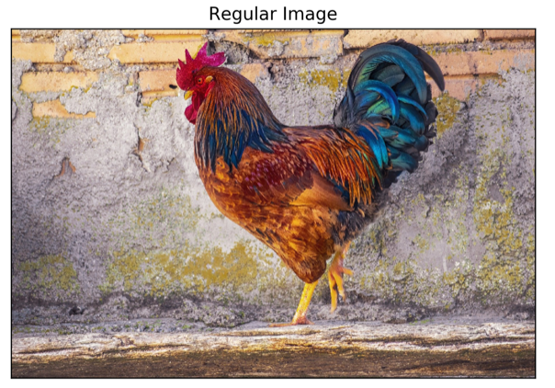

The goal was to be able to create first an image that was more red. The image was first converted into the LAB color space and thru trial and error adding and subtracting values to the A and B channels. The output is shown in figure 16 with an added value of 10 to the A channel and 3 to the B channel outputing a more red image.

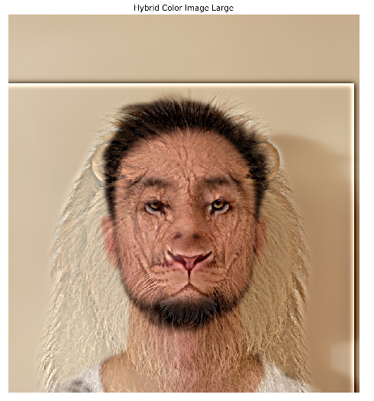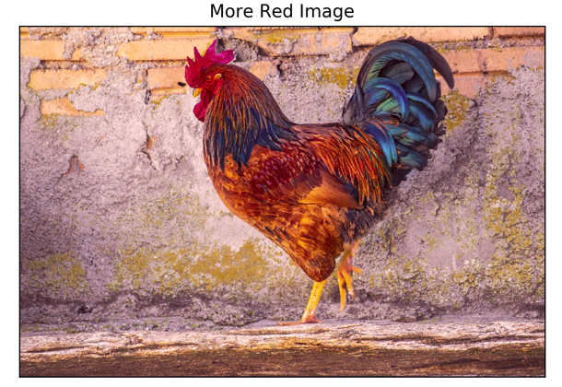

*figure 18*

*figure 16*

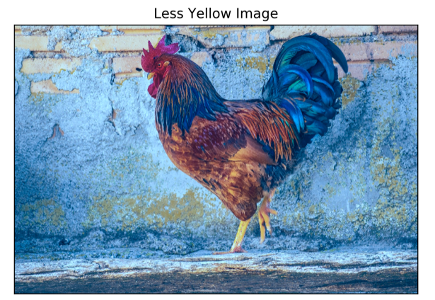The second part was to create an image that was less yellow. Again trial and error was implemented in the LAB color space and 30 was subtracted from the B channel and 10 was subtracted from the A channel outputing a less yellow and more blue image shown in figure 17.

*figure 17*

**Hybrid images in Color**

Going back to the hybrid images it was determined that using color in both the high and low frequency component was the best option. The high frequency image is harder to see up close because of the low frequncy parts still showing in the image. The final image is shown in figure 18. Figure 3 is the same hybrid image but done in gray scale.

**Gaussian and Laplacian pyramids**

The Laplacian and Gaussianpyramids are shown in figure 19 for the hybrid image shown in figure 3. To create a Gaussian pyramid, a low pass filter is applied to the image and then the image is subsampled. The process is then repeated for the subsampled image each time. The Laplacian is calculated by taking the pre filtered image and subtracting it from the Gaussian image each time down the pyramid.

